Helpful Guide to Chairing an Event or Program
ABE PTA 2018-2019
Dear Volunteer Chair,
Thank you so much for stepping up to lead an event or program. If it is your first time, we hope this Work Plan and Checklist will help you. If your event or program is ongoing or has already been approved, we hope the Checklist serves as a handy reminder.
Step 1: If it’s the first time, fill out your Work Plan. It will likely be general and preliminary, but it will give us the opportunity to coordinate necessary approvals and resources. And it will help whoever follows in your footsteps next year.
Step 2: Give your plan to your Vice-President at least one month before the event/program.
If the primary purpose of your event/program is to raise money, give your plan to the VP of Ways and Means.
If they primary purpose of your event/program is for an activity or service, give it to the VP of Programs.
If you aren’t sure, give it to the President.
This is to secure dates, places, people, and school approval…the School Principal must approve all events/programs! The PTA President or Vice-President will secure that approval to the best of their ability.
Step 3: Work your plan!
Remember, whatever you need – Volunteers, Money, Stuff – we will do our best to make it happen! Make sure to give the Volunteer Coordinator plenty of time (~2 weeks) to put together a SignUpGenius for volunteer sign-ups, if needed.
Thank you again for volunteering your time, energy, and skills; good luck!

Warmly,
Kate Ryder
PTA Volunteer Coordinator
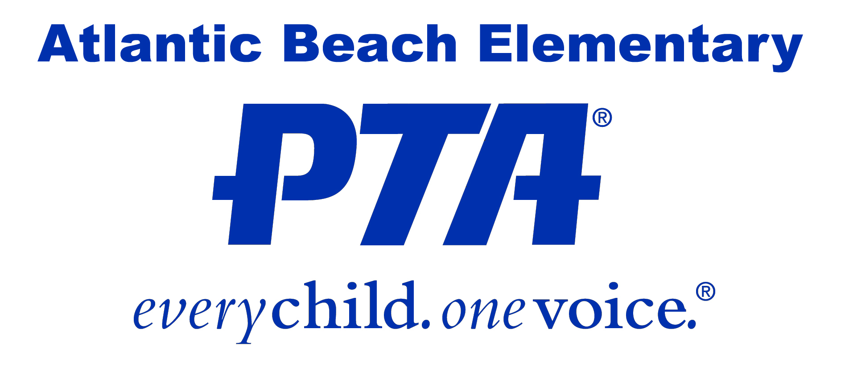

Work Plan
Program/Event:
Committee Chair Name and Contact Info:
Budget:
Please list general expenses/how budget will be used:

Event/program location:
Date and time of event/program:
Please give brief details on your event/ procedures: (ex. Will hold auditions 3 weeks in advance for the talent show. Rules of one act only for students. Will have chairs put in by county and remove cafeteria benches. Will sell drinks and pizza at event.)

Any additional/special equipment required at event:
Committee Members and Contact Info (if known):

Are any additional volunteers needed, and if so, who (PTA, homeroom moms, teachers, military, etc.), how many, and how do you plan to use them: (Please allow Volunteer Coordinator at least 3 weeks lead time).

What is your plan to publicize the program/event: (Please allow VP at least one week to obtain any necessary approvals.)

_______________________ ____________
Committee Chair Signature Date Submitted

