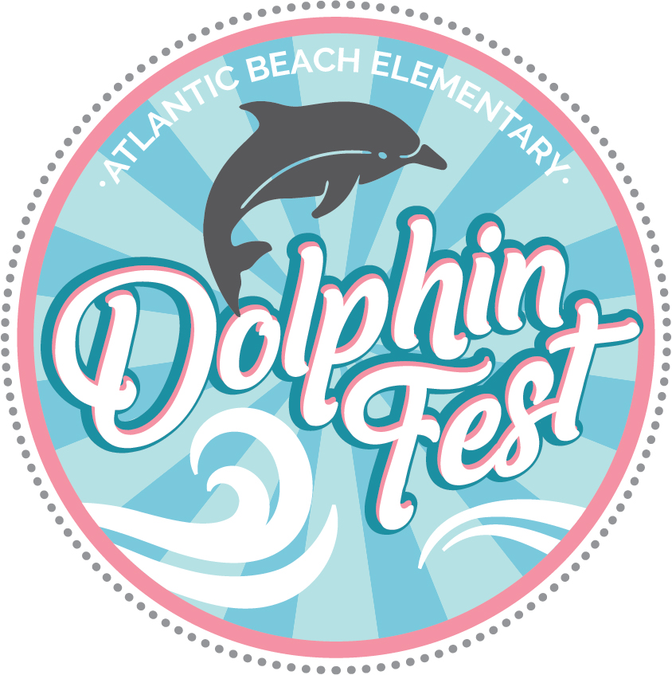

Atlantic Beach Elementary PTA Virtual Silent Auction 2020
September 1, 2020
Dear Sir or Madam:
I am reaching out to you on behalf of Atlantic Beach Elementary’s PTA, as we prepare to host our largest annual fundraiser. Due to Covid-19, this year our auction will be virtual and focusing on local businesses. We recognize that our local businesses have struggled during these past months and we want to show our love and support.
The success of our silent auction is made possible only by the generous donations from individuals and local businesses like yourself. We are sincerely hoping that you will consider donating this year to our fundraiser. All donations are tax-deductible, and it is a great way to be involved with our school and community. All donors receive recognition through our on-line marketing efforts, flyers, and brochures. This is a great opportunity to advertise and promote your business.
All proceeds from the event directly benefit our school. In addition to providing funds for the reading and book initiative program, the PTA also provides funds for new technology, vision and hearing screening, P.E. equipment, art and music supplies, cultural arts program, and the school garden. It is our mission to make every child’s potential a reality by engaging and empowering families and communities to advocate for all children. We hope you are able to support our mission, and thank you in advance for your consideration.
If you would like to make a donation, or have questions about this event, please feel free to contact us.

Sincerely,
Joy Carson  VP Programs  (770) 833-5904  lj_clif@hotmail.com | Margaux Jurasic  VP of Ways & Means  (904) 614-6811  star7985@aol.com

Atlantic Beach Elementary School PTA has been designated as a 501(c)(3) tax-exempt, nonprofit organization (EIN 23-7105802 / Tax Id 85-8012496176C-I). Donations are tax-deductible to the full extent allowed by law.
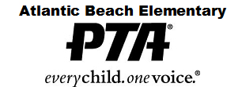

DONATION FORM
(Please Print)
Donor Information:
Company Name: __________________________________________________
Contact Person: __________________________________________________
Address: __________________________________________________
__________________________________________________
City, State, Zip: __________________________________________________
Phone: __________________________________________________
Email: __________________________________________________

DETAILS:
ITEM DESCRIPTION: __________________________________________________
Value: __________________________________________________
Terms/Conditions/Blackout days/Expiration date: ________________________________________________________________________________________________________________________________________________________________________________________________________________________
Method of Delivery:
_____ Please pick up Item (date item will be ready to pick up _____________________)
_____ Will send item to school**
**Please label item being delivered to school with your name and ATTN: Dolphin Fest Donation

Feel free to contact event chairs with any questions:
Joy Carson Margaux Jurasic
VP Programs VP of Ways and Means
(770)833-5904 (904)614-6811
lj_clif@hotmail.com star7985@aol.com

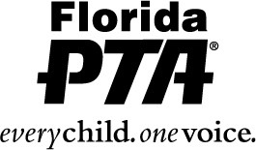
Cindy Gerhardt, President
Linda Kearschner, President Elect
Jen Martinez, VP of Leadership Development
Carolyn Nelson-Goedert, VP of Regions/Councils
1747 Orlando Central Parkway Linda Nestor, VP of Membership Development
Orlando, FL 32809 Joseph Gebara, VP of Educational Development
www.FloridaPTA.org Katrena McMahan, Treasurer
407855-7604 / 1/800-373-5782 Kathy Thrumston, Secretary
Fax: 407/240-9577
________________________________________________________________________________________________________________________

July 25, 2017

To Whom It May Concern:
This is to certify that Atlantic Beach Elementary PTA in Duval County is an active PTA. They are a subordinate organization, under our group exemption, GEN 2149, of the Florida Congress of Parents and Teachers. This PTA was originally chartered on March 4, 1940, and their EIN is 23-7105802.
All funds raised should be used for the enrichment of Atlantic Beach Elementary PTA and the students.
Any check(s) or donation(s) should be made to the Atlantic Beach Elementary PTA.
Florida Congress of Parents And Teachers, Inc., (d.b.a. Florida PTA), is a 501 (c) (3) nonprofit organization. A copy of the determination letter is attached hereto.
If you have any questions, please contact me at the above number.
Very truly yours,
Jean Hovey
Jean Hovey
Florida PTA

