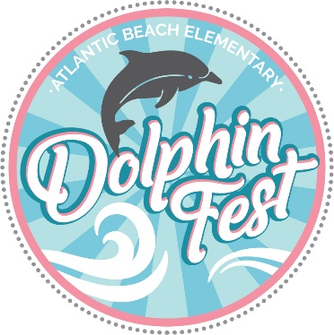

2020 ABE PTA’s Silent Auction Donations Are Welcome!

Dolphin Fest is quickly approaching; If you would like to make a donation for our silent auction, please don’t be shy! Due to Covid-19, we are focusing all our efforts on a virtual silent auction that supports our local businesses. We welcome contributions from all businesses: home businesses, families, faculty, and bus stop friends. Items do not have to fit in a basket! Do you have a spare time at a vacation home or condo to donate? How about a hand painted picture frame or a collection of items from your home business? There will be something available for everyone and you don’t want to miss it! Donations must be received by Tuesday October 27th to guarantee that they will appear in our brochure.

If you would like to make a donation, please contact Joy Carson or Margaux Jurasic due to Covid-19.

***DOLPHIN FEST SILENT AUCTION DONATION DETAILS ***
Donor Name: ________________________________________________________________
Contact info: ________________________________________________________________
Company Name: _____________________________________________________________
Description of Donation:________________________________________________________
Approximate Value of Donation:_$_________________

Please contact us with any questions Margaux Jurasic at star7985@aol.com or (904) 614-6811 Joy Carson at lj_clif@hotmail.com or (770) 833-5904
