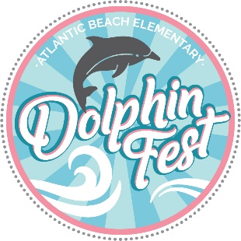
Silent Auction: SATURDAY, NOVEMBER 7th
10:00AM-2:00PM @ Online website to be announced
HOMEROOM PARENT INFORMATION

Due to the changes for COVID this year, the PTA has cancelled the outside portion of Dolphin Fest. Even though the outside activities have been cancelled, the silent auction and class raffles will still be happening.
The Dolphin Fest silent auction will be held as a completely virtual event on Saturday, November 7th from 10am-2pm. The event includes class basket raffles, auction items donated from our wonderful local businesses and a teacher treat auction.
Dolphin Fest is the largest PTA fundraiser of the year, and we need your help to make it a success! We are asking homeroom parents from each CLASS to make one themed basket that will used for the event’s class basket drawing.

HERE ARE THE DETAILS:
CLASS BASKETS: Homeroom parents are responsible for collecting items for the classroom basket and assembling the finished basket. When collecting for the basket, you can ask for monetary donations to purchase the items, or you can request that each student bring in an “item” that matches the theme your teacher selected. Please provide your classroom with a box or bin, and envelope to collect the items as the children bring them to class. Higher priced items/gift cards/or monetary donations need to be saved by the homeroom parent, as WE ARE NOT ALLOWED TO LEAVE CASH AT SCHOOL. Also, do not forget to purchase or collect a basket or container to use to hold your items. Please be mindful of size when you are purchasing to make sure all items fit inside. The finished “basket” needs to be fully enclosed in cellophane or Shrink Wrap to make for easier transport and to prevent items disappearing from basket during event.
ALL CLASS BASKETS ARE DUE TUESDAY, OCTOBER 27th! When asking for donations from classroom parents, please keep in mind this deadline, and give yourself enough time to assemble the basket. Please be sure to attach the Class Basket Detail Sheet to the basket. The baskets will be displayed online Friday, October 30th.

***Please let us know if you need any assistance with your class basket, we are happy to help. Also, if you have a business, know of a business, or frequent a business that would like to donate to our silent auction, please let us know! Thank you for your support, we are looking forward to a great Dolphin Fest!

Dolphin Fest Chairs
Margaux Jurasic (star7985@aol.com)
Joy Carson (lj_clif@hotmail.com)

CLASS BASKET DESCRIPTION FORM

HOMEROOM TEACHER:_____________________________________

GRADE:_____________________________________________________

BASKET NAME:______________________________________________

HOMEROOM PARENT NAME:________________________________

HOMEROOM PARENT PHONE#:______________________________

HOMEROOM PARENT EMAIL:________________________________

APPROX. VALUE OF BASKET:________________________________

BRIEF DESCRIPTION OF WHAT’S INCLUDED IN BASKET:__________________________________________________________________________________________________________________________________________________________________________________________________________________________________________________________________________________________________________________________________________________________________________________________________________________________________
________________________________________________

